Smart Campus Navigation

Introduction
This comprehensive report integrates all the project components provided:
1. Week-1 AI-Based Campus Navigation System (Graph Pathfinding).
2. Bot Brain – Smart Campus Chatbot.
3. Campus Navigation Web Application (Leaflet-based frontend).
4. Complete backend and frontend code implementation.
The goal is to create a smart, interactive campus navigation solution for Chanakya University.

Week-1: AI-Based Campus Navigation System
The AI-based system models the campus as a weighted graph where nodes represent buildings and edges represent routes. It applies BFS, DFS, Uniform Cost Search, and A* algorithms to compute efficient routes between locations, allowing students and visitors to easily navigate campus facilities.

Bot Brain – Smart Campus Chatbot
Bot Brain is a natural language processing chatbot that answers FAQs and provides navigation assistance. It integrates with Google Maps API and a campus database to provide instant responses and directions, reducing reliance on manual help desks.

Campus Navigation Web Application
An interactive web application built with Leaflet.js allows users to select start and end points to visualize routes, distance, and estimated walk time. The application features a responsive interface that works seamlessly across devices.
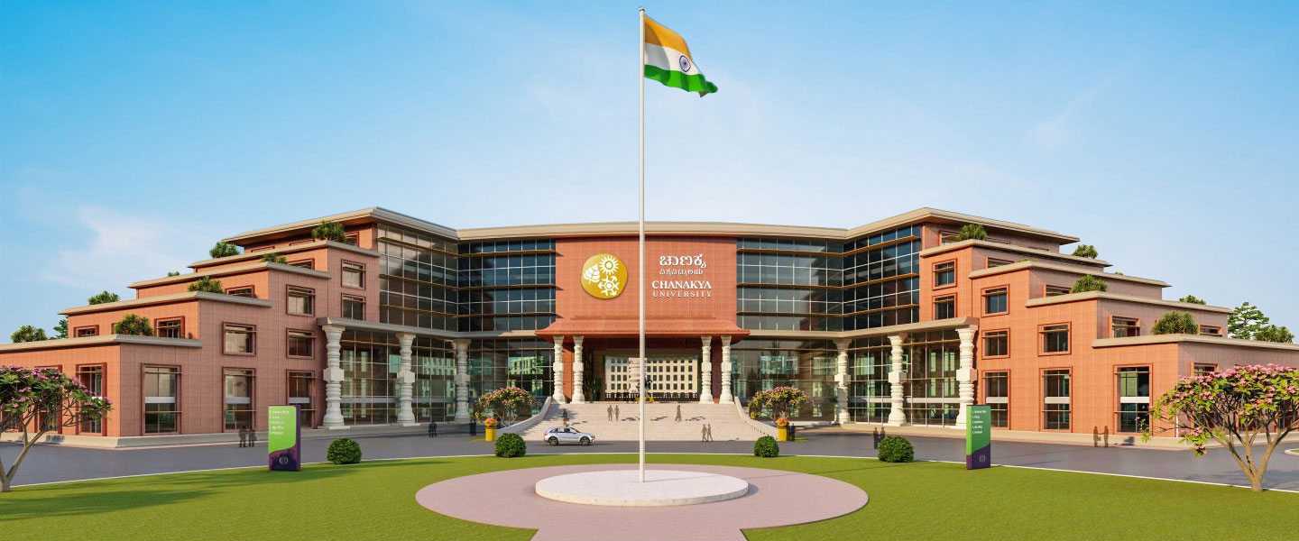

Backend Code (Flask API)
from flask import Flask, jsonify, request
from math import sqrt
import heapq
app = Flask(__name__)
NODES = {
"Main Gate": (13.2201951,77.7541421),
"Gate 2": (13.2213743,77.7551241),
"ACADEMIC A": (13.2221283,77.7552384),
"ACADEMIC B": (13.2233225,77.7559227),
"Food Court": (13.2247972,77.7571941),
"Hostel 1": (13.2245171,77.7588691),
"Volleyball Court": (13.2286181,77.7583193),
"Cricket Ground": (13.228393,77.757574),
"Laundry": (13.2244904,77.7571404),
"MART": (13.2245579,77.7591752)
}
GRAPH = {
"Main Gate": {"Gate 2": 150, "ACADEMIC A": 250},
"Gate 2": {"Main Gate": 150, "ACADEMIC A": 150, "ACADEMIC B": 300},
"ACADEMIC A": {"Main Gate": 250, "Gate 2": 150, "ACADEMIC B": 150, "Food Court": 300},
"ACADEMIC B": {"Gate 2": 300, "ACADEMIC A": 150, "Food Court": 200},
"Food Court": {"ACADEMIC A": 300, "ACADEMIC B": 200, "Hostel 1": 200, "Laundry": 80},
"Hostel 1": {"Food Court": 200, "MART": 150},
"Volleyball Court": {"Cricket Ground": 100, "MART": 400},
"Cricket Ground": {"Volleyball Court": 100, "ACADEMIC B": 500},
"Laundry": {"Food Court": 80, "MART": 100},
"MART": {"Hostel 1": 150, "Laundry": 100, "Volleyball Court": 400}
}
def heuristic(a, b):
(x1, y1), (x2, y2) = NODES[a], NODES[b]
return sqrt((x1 - x2)**2 + (y1 - y2)**2)
def a_star(start, end):
pq = [(0 + heuristic(start, end), 0, start, [start])]
visited = set()
while pq:
est, cost, node, path = heapq.heappop(pq)
if node == end:
return {"path": path, "distance_m": cost}
if node in visited:
continue
visited.add(node)
for neighbor, w in GRAPH[node].items():
if neighbor not in visited:
heapq.heappush(pq, (cost + w + heuristic(neighbor, end), cost + w, neighbor, path + [neighbor]))
return None
@app.route("/locations")
def locations():
return jsonify([{"name": k, "lat": v[0], "lng": v[1]} for k, v in NODES.items()])
@app.route("/route")
def route():
start = request.args.get("start")
end = request.args.get("end")
if not start or not end:
return jsonify({"error": "start and end required"}), 400
if start not in GRAPH or end not in GRAPH:
return jsonify({"error": "unknown location"}), 404
result = a_star(start, end)
return jsonify(result)
if __name__ == "__main__":
app.run(debug=True)

Frontend Code (HTML/JavaScript)
<!DOCTYPE html>
<html lang="en">
<head>
<meta charset="UTF-8" />
<meta name="viewport" content="width=device-width, initial-scale=1.0"/>
<title>Campus Navigation</title>
<link rel="stylesheet" href="https://unpkg.com/leaflet@1.9.4/dist/leaflet.css"/>
<script src="https://unpkg.com/leaflet@1.9.4/dist/leaflet.js"></script>
</head>
<body>
<div class="controls">
<label>Start: <select id="start"></select></label>
<label>End: <select id="end"></select></label>
<button onclick="getRoute()">Navigate</button>
<span id="info"></span>
</div>
<div id="map"></div>
<script>
const API_BASE = "http://localhost:5000";
let map = L.map('map').setView([13.223,77.756], 16);
L.tileLayer('https://{s}.tile.openstreetmap.org/{z}/{x}/{y}.png').addTo(map);
async function loadLocations(){
const res = await fetch(`${API_BASE}/locations`);
const data = await res.json();
data.forEach(l=>{
document.getElementById('start').add(new Option(l.name,l.name));
document.getElementById('end').add(new Option(l.name,l.name));
L.marker([l.lat, l.lng]).addTo(map).bindPopup(l.name);
});
}
loadLocations();
async function getRoute(){
const s = document.getElementById('start').value;
const e = document.getElementById('end').value;
if(s === e){ alert("Start and End cannot be same"); return; }
const res = await fetch(`${API_BASE}/route?start=${encodeURIComponent(s)}&end=${encodeURIComponent(e)}`);
const data = await res.json();
if(data.error){ alert(data.error); return; }
const locRes = await fetch(`${API_BASE}/locations`);
const locs = await locRes.json();
const lookup = Object.fromEntries(locs.map(l => [l.name, [l.lat, l.lng]]));
const latlngs = data.path.map(p => lookup[p]);
L.polyline(latlngs, {color:'blue'}).addTo(map);
map.fitBounds(latlngs);
document.getElementById('info').textContent = `Distance: ${data.distance_m} meters`;
}
</script>
</body>
</html>

Integration & Future Scope
The backend and frontend together create a dynamic, scalable, and user-friendly navigation system. Future enhancements could include indoor navigation, voice-based assistance, and AR-based directions.

